H.T No
Regulations:
A17


Sreenidhi Institute of Science and Technology
(An Autonomous Institution)
Code No: 6D301 Date: 20-Dec-2019 (FN)

B.Tech II-Year I-Semester External Examination, Dec-2019/Jan-2020 (Supplementary)
DISCRETE STRUCTURES AND GRAPH THEORY (ECM)

Time: 3 Hours Max.Marks:75

Note: a) No additional answer sheets will be provided.
b) All sub-parts of a question must be answered at one place only, otherwise it will not be valued.
c) Missing data can be assumed suitably.

Part - A Max.Marks:25

Answer all QUESTIONS.

1. | Using the statements : R: John is Healthy H: John is clever  Write the following statements in symbolic form.  (i) If John is healthy the he is not clever (ii) John is not healthy but clever. | [3M]
2. | If the universe of discourse is 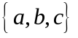eliminate the quantifier from the formula 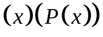 | [3M]
3. | Give an example of a lattice which is distributive but not complemented . | [3M]
4. | Enumerate the number of ways of placing 20 indistinguishable balls into 5 boxes where each box is non-empty. | [3M]
5. | Define recurrence relation. | [3M]
6. | Is there a graph with degree sequence (1, 3, 3, 3, 5, 6, 6) Give reasons. | [2M]
7. | State Euler’s formula for planar Graphs. | [2M]
8. | Give an example of a relation which is both symmetric and anti-symmetric. | [2M]
9. | Find the coefficient of X²⁰ in (X3+X4+X5…..)⁵ | [2M]
10. | Construct the truth table for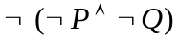. | [2M]
Part – B Max.Marks:50
ANSWER ANY FIVE QUESTIONS. EACH QUESTION CARRIES 10 MARKS.

11. | a) | Show that is a tautology without constructing the truth table. | [5M]
 | b) | Show that the following premises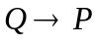,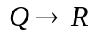,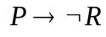,  are inconsistent. | [5M]
12. | a) | Show that | [5M]
 | b) | Show that from and 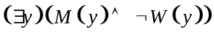 the conclusion 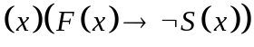follows. | [5M]
13. | a) | Show that in a lattice 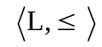 if 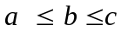 then.  (i) 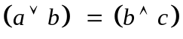. (ii) | [5M]
 | b) | Given 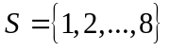 and a relation  on where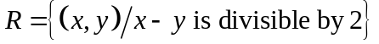, prove that R is an equivalence relation. Draw the graph of R and also write the matrix of R. | [5M]
14. | a) | Find the number of numbers between 1 and 500 (both inclusive) which are divisible by 3 or 5 or 7. How many of them are divisible by 3 or 7 but not by 5. | [5M]
 | b) | How many integral solutions are there 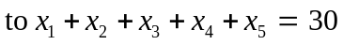where each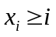. | [5M]
15. | a) | Find a recurrence relation for number of transfers required to move disks and solve it. | [5M]
 | b) | Solve the recurrence relation using generating functions. | [5M]
16. | a) | Define an Eulerian graph. Construct if possible, an Euler graph with 6 vertices and 10 edges and justify your answer. | [5M]
 | b) | Prove that a complete graph 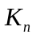is planar iff 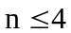. | [5M]
17. | a) | Let 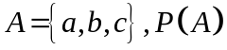 is the power set of  Let  be the inclusion relation on the elements of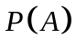. Draw Hasse diagram of 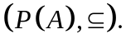 | [5M]
 | b) | Explain about automatic theorem proving with an example. | [5M]
18. | a) | A complete bipartite graph 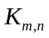 is planar iff 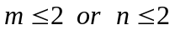 | [5M]
 | b) | Find the coefficient of | [5M]

-- 00 -- 00 –

